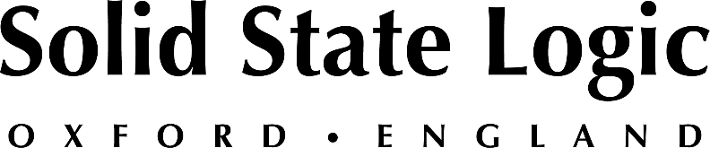

**Solid State Logic Unearths Free New Halloween-Themed Plug-In, X-Orcism II: Voices from the Crypt**

*Get inspired by a touch of the supernatural this Halloween with SSL's spooky free new plug-in*   
*and take advantage of limited-time SSL plug-in promotions*

**Oxford, England, October 25, 2024 — The sonic alchemists at Solid State Logic have unearthed a spooky new plug-in just in time for Halloween - the SSL X-Orcism II: Voices from the Crypt. The new X-Orcism II, available as a free, unrestricted download, packs several Halloween-themed FX into a single plug-in for voice transformation including delay, pitch shifting, reverb, noise generation and more. More than just a spooky effect for Halloween, X-Orcism II is ideal for sound design, game development, music production, or any project that requires a touch of the supernatural.**

X-Orcism II is a professional-grade production tool with intuitive controls, making it easy to manipulate any audio source into a hauntingly immersive soundscape. Layer your voice with whispers from the beyond using the Echoes and Crypt Size parameters or summon restless spirits with the Howl control: a noise generator that evokes the haunting beauty of desolate landscapes, which can be automated to build sonic rises and falls. Dive further into the black abyss with the Tombverb control or use Ghoul and Wail to create unsettling pitch shifts.

**Otherworldly sounds from the great beyond**  
Useful well beyond the spooky season, X-Orcism II is an inspiring music production tool, perfect for imparting FX for experimental record or film production. Beyond vocal processing, X-Orcism II is capable of delivering otherworldly sounds when paired with synthesizers or producing dystopian tones when paired with guitars.

**Key features:**

* Powerful delay, pitch shifting, reverb, and noise generation capabilities for supernatural tones.
* Ideal for a wide range of applications including sound design, game development, music production, podcasting, and live performances.
* Intuitive, automatable parameters such as Echoes, Crypt Size, Howl, Tombverb, Ghoul, and Wail to create dynamic soundscapes.
* Resizable GUI to suit custom workspaces.
* Accessible for visually impaired, with on-screen reader support and keyboard navigation and contextual help for controls.
* Built-in contextual help with clear labels and helpful tooltips.
* Built-in producer presets, and preset management system and for use among different DAWS.

X-Orcism II is an essential FREE addition to any producer’s plug-in library and is available in VST, VST, AU, and AXX formats. For more information and to download X-Orcism II for free, please visit the [SSL eStore](https://store.solidstatelogic.com/).

**Pick & Mixing Halloween Special – Starts 30th October!**

In addition to providing X-Orcism II as a free download, SSL is also offering special Halloween promotions starting Wednesday, October 30th, on several other plug-ins. Customers can take advantage of a “Pick & Mix” 3-for-2 offer or a 5-for-3 offer on any SSL plug-in in the e-store. Limited-time discounts on existing plug-ins include:

* X-EQ2 at $29.99
* X-Echo at $24.99
* X-ValveComp at $19.99

For more information on SSL's plug-ins, or to learn more about the SSL Complete Bundle subscription, please visit: <https://www.solidstatelogic.com/products/ssl-complete-bundle-subscription>.

*Solid State Logic is the world’s leading manufacturer of analogue and digital audio consoles and provider of creative tools for music, broadcast, live and post production professionals. For more information about our award-winning products, please visit: www.solidstatelogic.com.*

###

For further information contact:

**Jeff Touzeau**

+1 (914) 602-2913

jeff@hummingbirdmedia.com

**Ross Gilbert**

+44 (0) 1865 842300

rossg@solidstatelogic.com